**5. NONFUNCTIONAL REQUIREMENTS**

**5.1. PERFOMANCE REQUIREMENTS**

**NORMALIZATION:**

* **E-R diagram in 3NF:**

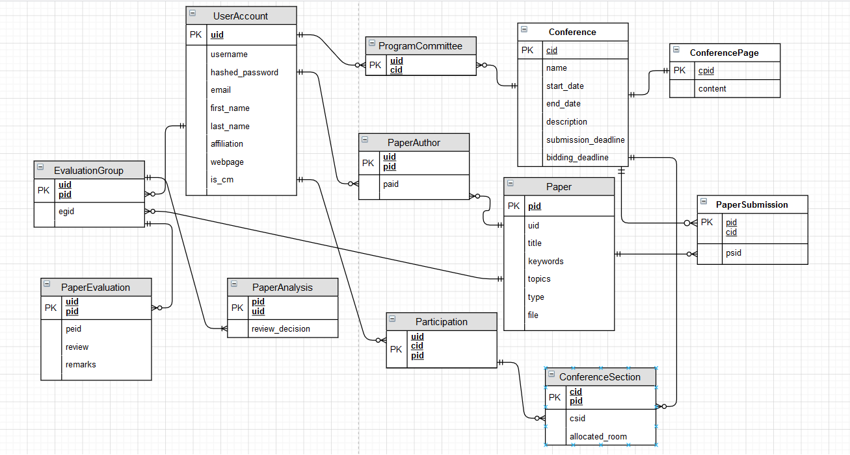

**5.2 SAFETY REQUIREMENTS**

If there is extensive damage to a wide portion of the database due to catastrophic failure, such as a disk crash, the recovery method restores a past copy of the database that was backed up to archival storage (typically tape) and reconstructs a more current state by reapplying or redoing the operations of committed transactions from the backed up log, up to the time of failure.

**5.3 SECURITY REQUIREMENTS**

Security systems need database storage just like many other applications.

**5.4 SOFTWARE QUALITY ATTRIBUTES**

* **AVAILABILITY:** There should be enough available rooms for each section of the conference, considering the number of participants for each section.
* **CORRECTNESS:** A paper should be presented at the corresponding section of the conference.
* **MAINTAINABILITY:** The chair members should maintain correct assignation of the submitted papers to the PC members.
* **USABILITY:** The conference topics should get as much user interest as possible.